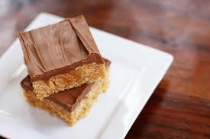
Special K Bars
1 cup sugar
1 cup light karo syrup
1 cup peanut butter
6 cups Special K cereal
1 cup milk chocolate chips
1 cup butterscotch chips
- In a large bowl, measure out your 6 cups of Special K cereal and set aside.
- Bring to a full boil sugar and karo syrup. Remove from heat when mixture reaches a full boil.
- Add peanut butter and stir until smooth.
- Add hot mixture quickly to the 6 cups of cereal and mix thoroughly until well coated.
- Melt both kinds of chocolate chips together in a microwave safe bowl for 2 minutes, stir, and continue to microwave 30 seconds at a time and stirring if needed until melted. Careful to not over cook the chocolate.
- When smooth, spread over mixture in pan. Let set, cut, and serve.

